#1 Speed (pages 332–334) Name: _____________ Period: _____
Motion and Forces HW
1. Define speed.
2. The equation used for calculating average speed is .
3. A student walked 1.5 km in 25 minutes, and then, realizing he was
late, ran the remaining 0.5 km in 5 minutes. Calculate his average
speed on the way to school.

Graphing Motion (page 334)
4. The slope of a line on a distance-time graph represents.
For questions 9 through 11, refer to the graph below.
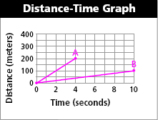

5. Draw a point on the graph that represents 200 m traveled in
4 seconds. Draw a line connecting this point with the origin (0,0).
Label this as line A.
6. Draw a point on the graph that represents 100 m traveled in
10 seconds. Draw a line connecting this point with the origin (0,0).
Label this as line B.
7. Calculate the average speed (slope) of lines A and B. Be sure to
include units.
Velocity (page 336)
8. How do speed and velocity differ?
9. Is the following sentence true or false? If a car travels around a
gentle curve on a highway at 60 km/h, the velocity does not
change.
Calculating Acceleration (pages 345–346)
10. Write the equation used to calculate the acceleration of an object.

11. Is the following sentence true or false? When the final velocity is
less than the initial velocity of an object, the acceleration is
negative. Keep going this night’s HW is two pages!
12. A skateboarder begins down a ramp at a speed of 1.0 m/s. After
3 seconds, her speed has increased to 4.0 m/s. Calculate
her acceleration.
a. 1.0 m/s² b. 3.0 m/s²
c. 5.0 m/s² d. 9.8 m/s²
Graphs of Accelerated Motion (pages 346–348)
13. A speed-time graph in which the displayed data forms a straight
line is an example of a(n) .
For questions 14 through 18, refer to the graphs below.
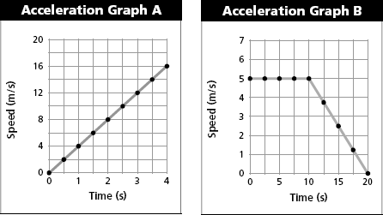

14. Graph A represents the motion of a downhill skier. How fast was the skier moving
after traveling down the hill for 2.5 seconds?
15. In which graph does an object move at constant speed during the
first 4 seconds?
16. Graph B represents the motion of a mountain biker. What is the biker’s
speed at times of 10 s and 20 s?
17. Determine the acceleration of the mountain biker during the
10 second to 20 second time period. Show your work.

18. The plotted data points representing acceleration in a distance-time
graph form a(n) .
Instantaneous Acceleration (page 348)
19. The measure of how fast a velocity is changing at a specific instant
is known as .

Teacher Stamp/Initial

#2 Newton’s First Law of Motion (pages 364–365)
1. Is the following sentence true or false? According to Newton’s first
law of motion, an object’s state of motion does not change as long as
the net force acting on it is zero.

- Is the following sentence true or false? The law of inertia states
that an object in motion will eventually slow down and come to a
complete stop if it travels far enough in the same direction.
Newton’s Second Law of Motion (pages 365–368)
3. According to Newton’s second law of motion, acceleration of an
object depends upon the of the object and
the acting on it.
4. Is the following sentence true or false? The acceleration of an
object is always in the same direction as the net force acting on
the object.
5. Is the following sentence true or false? If the same force acts upon
two objects with different masses, the acceleration will be greater
for the object with greater mass.

Newton’s Third Law (page 373)
6. According to Newton’s third law of motion, what happens whenever
one object exerts a force on a second object?

7. The equal and opposite forces described by Newton’s third law are
called and forces.
8. Circle the letters that identify each sentence that is true about
action-reaction forces.
a. Newton’s second law describes action-reaction forces.
b. Forces always exist in pairs.
c. Action-reaction forces never cancel.
d. All action-reaction forces produce motion.
9. Is the following statement true or false? Action-reaction forces do
not cancel each other because the action force is always greater than
the reaction force.

Teacher Stamp/Initial

#3 Momentum (pages 374–375)
1. Circle the letter of each factor that affects the momentum of a
moving object.
a. mass | b. volume | c. shape | d. velocity
2. If two identical objects are moving at different velocities, the object
that is moving faster will have momentum.
3. Your in-line skates are sitting in a box on a shelf in the closet. What
is their momentum?
4. Is the following sentence true or false? An object with a small mass
can have a large momentum if the object is traveling at a high
speed.
5. Write the momentum formula, including the correct units.

6. Circle the letter of the object that has the greatest momentum.
a. a 700-gram bird flying at a velocity of 2.5 m/s
b. a 1000-kilogram car traveling at 5 m/s
c. a 40-kilogram shopping cart rolling along at 0.5 m/s
d. a 300-kilogram roller coaster car traveling at 25 m/s
Conservation of Momentum (pages 376–377)
7. What does conservation of momentum mean?

8. According to the law of conservation of momentum, what happens
to the total momentum of a system if no net force acts on the system?

9. Is the following sentence true or false? In a closed system with two
objects, the loss of momentum of one object equals the gain in
momentum of the other object.
For questions 10 and 11, refer to the graph below.
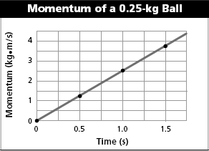

10. The momentum of the ball at one second is .
11. What is the speed of the ball at 0.5 seconds? Show your
calculation. Hint: Solve the momentum formula for velocity.

