Name ________________________

Chapter 10 Notes: Nuclear Chemistry

- Radioactivity: the process in which an _________________ atomic __________________ emits charged particles of energy.
Draw atom:
Draw radioisotope (unstable):

  - The atoms of one element can _________________ into atoms of a _____________________ element.
    - Example: Uranium will decay into _____ different elements until it becomes ________ lead
    - Example: Carbon-___ decays into ________________
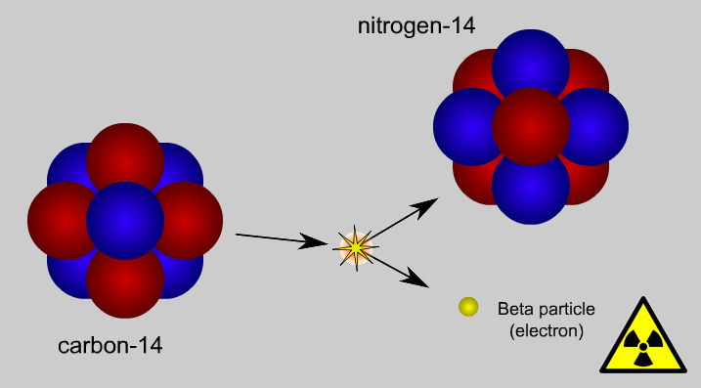

  - Types of decays:
    - ____________ : Positive particle -_____ protons and _______ neutrons (_______________ atom)
    - _____________: an electron
    - ________________: a _______ of penetrating energy
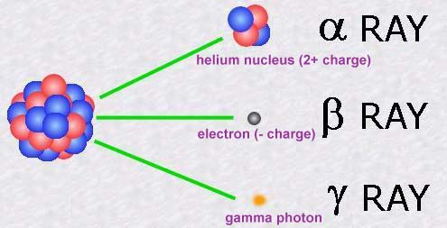

  - The particles and energy can ________ bonds in _______.
    - What does this mean for humans? _______________
____________________________________________________________________________________________________________

  - It can be detected with ___________ counters or film badges.

- Half-life: the time required for _________ of a sample of a radioisotope to ___________.

If you 100 particles and half-life is 10 years, figure out the amount of particles after each half-life:

Half-Life=0 | 1 | 2 | 3 | 4 | 5 | 6
100 particles
How many times can you cut a piece of paper in ½ ? ______
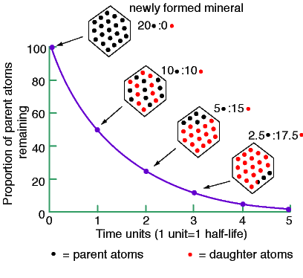
  - Rates are _________________
  - Carbon-____ is used to determine the ____ of an object.
- Strong Nuclear Force: The _________ that holds neutrons and protons together in the ___________________.
  - In unstable nuclei, the _______________ the nucleus the more _____________________ the isotope.
  - When the strong nuclear force is ________________ by the repulsive _______________ force, the isotope becomes unstable.
  - All elements with more than ________ protons are unstable.
- Nuclear Fission: the _________________ of an atomic nucleus into ________ smaller parts.
  - Produces a tremendous amount of __________________
  - Mass is ______________________ into Energy
    - Used in nuclear power ________ & atomic ________
    - E = _________

  - Chain Reactions: when _______________ released during the ________ initial nucleus trigger a _________ of nuclear fissions.
    - Used to make nuclear _______ and generate ________ plants

- Nuclear Fusion: nuclei of ______ atoms combine to form a ______________ nucleus
  - Produces ________________
  - The __________ is powered by fusion of _______________ into Helium
  - Hydrogen __________________

FUSION FISSION

H.1.P1-State Standard: Explain how the composition of the nucleus is related to isotopes and radioactivity.

