Name ________________________

Chapter 10 Notes: Nuclear Chemistry

- Radioactivity: the process in which an unstable atomic nucleus emits charged particles of energy.
Draw atom:
Draw radioisotope (unstable):

  - The atoms of one element can change into atoms of a different element.
    - Example: Uranium will decay into 13 different elements until it becomes stable lead
    - Example: Carbon-14 decays into Nitrogen
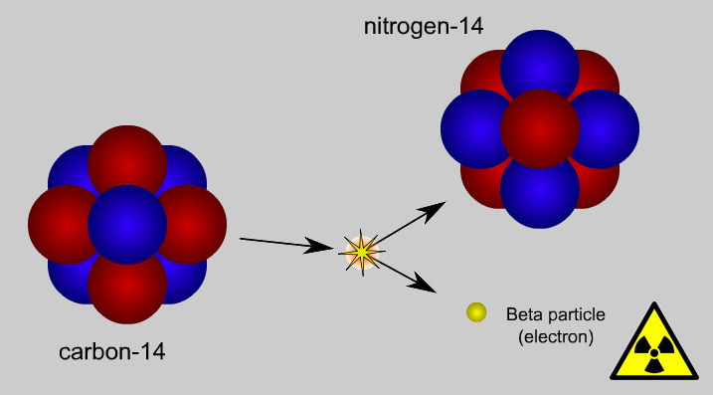

  - Types of decays:
    - Alpha : Positive particle -two protons and two neutrons (Helium atom)
    - Beta: an electron
    - Gamma: a ray of penetrating energy
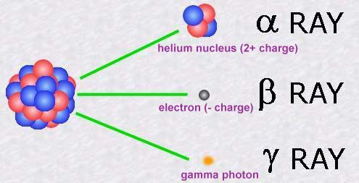

  - The particles and energy can break bonds in DNA.
    - What does this mean for humans? _______________
____________________________________________________________________________________________________________

  - It can be detected with Geiger counters or film badges.

- Half-life: the time required for one half of a sample of a radioisotope to decay.

If you 100 particles and half-life is 10 years, figure out the amount of particles after each half-life:

Half-Life=0 | 1 | 2 | 3 | 4 | 5 | 6
100 particles
How many times can you cut a piece of paper in ½ ? ______
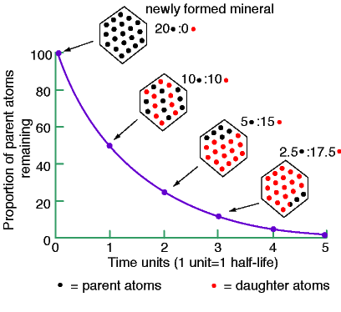
  - Rates are constant
  - Carbon-14 is used to determine the age of an object.
- Strong Nuclear Force: The force that holds neutrons and protons together in the nucleus.
  - In unstable nuclei, the larger the nucleus the more unstable the isotope.
  - When the strong nuclear force is overcome by the repulsive electric force, the isotope becomes unstable.
  - All elements with more than 83 protons are unstable.
- Nuclear Fission: the splitting of an atomic nucleus into two smaller parts.
  - Produces a tremendous amount of energy
  - Mass is converted into Energy
    - Used in nuclear power plants & atomic bomb
    - E = MC²

  - Chain Reactions: when neutrons released during the first initial nucleus trigger a series of nuclear fissions.
    - Used to make nuclear bomb and generate power plants

- Nuclear Fusion: nuclei of two atoms combine to form a larger nucleus
  - Produces energy
  - The sun is powered by fusion of Hydrogen into Helium
  - Hydrogen bomb

FUSION FISSION

H.1.P1-State Standard: Explain how the composition of the nucleus is related to isotopes and radioactivity.

