Energy Transfer

First Law of Thermodynamics:

Second Law of Thermodynamics:



1. The Sun undergoes ____________________ fusion reactions, which releases _________________________________ and ______________________________ energy.

2. ENERGY – energy travels to Earth in the form of _______________________________.

3. _______________________________________________ energy. In the presence of energy, carbon dioxide and water undergo a chemical reaction and produce sugar. This process is called ______________________________________.

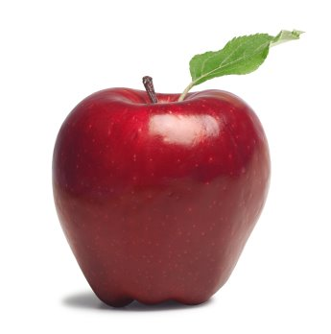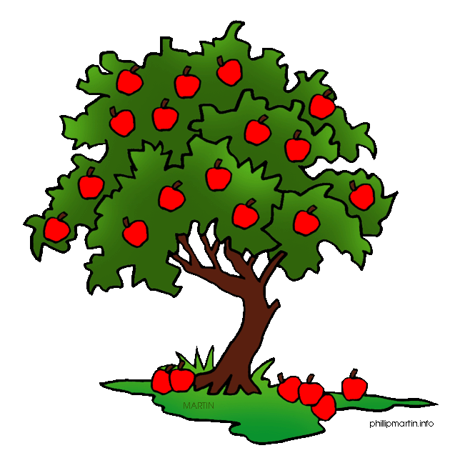

4. _______________________ energy. Animals eat plants to get energy that is stored in sugar.

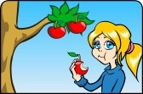

6. Animals have the ability to move and do all kinds of work to transform chemical energy into _______________________ and _____________________ energy.

5. Chemical energy – the body breaks down _________________ I the chemical reactions of digestion to obtain energy.

**Energy Conversions**

*Show the energy conversions that take place by filling in the blanks*.

is

In a(n) starting energy converted final energy

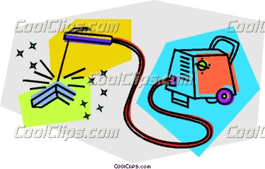 to

1.

______________________ ________________________

[](javascript:edit(12330))

2. ______________________ ________________________



3. ______________________ ________________________

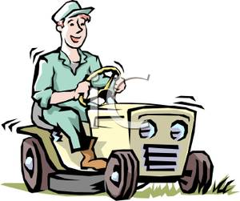

4. ______________________ ________________________

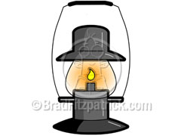

5. ______________________ ________________________

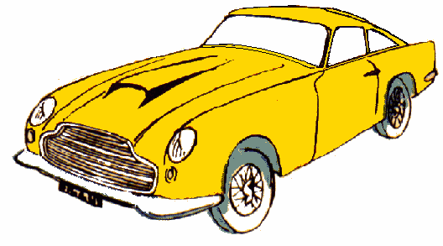

6. ______________________ ________________________



7. ______________________ ________________________

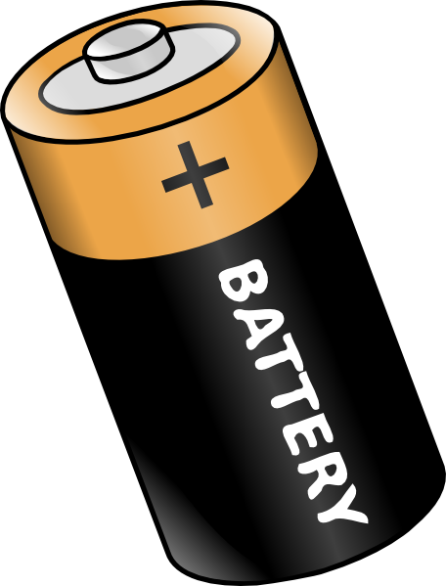

8. ______________________ ________________________