Name: ____________________ Period:________ Space Test Study Guide…Do it!!! It’s a way of life!

H1E1 Classify bodies in Solar System (properties and composition)
Describe attributes of our galaxy and evidence of multiple Galaxies.

____1. Explain why the planets remain in motion around the sun?

____2. What are Solar Winds?

____3. What is a pulsar?

____4. Compare and Contrast the inner and outer planets.

____5. Describe an asteroid.

____6. What is the difference between a meteoroid and a meteorite?

Completion Complete each statement using the following words. (Not all words used)
Asteroid Kuiper Distance Mass Core Moons
Surface Size Rocks Universe 1 2 3 gravity

Astroid Kuiper Distance Mass Core Atmospheres
Surface Size Rocks Universe 1 2 3 gravity

Astroid Kuiper Distance Mass Core Atmospheres
Surface Size Rocks Universe 1 2 3 gravity

7. Stars and galaxies are held together by ____________________.
8. The number of universes known to exist is _______.
9. All of the planets in our solar system have ________________with the exception of Mercury and Venus.
10. Nuclear fusion within the sun takes place within the ____________.
11. The ___________ belt contains perhaps tens of thousands of objects orbiting within about 100 AU of the sun.
12. What two things affect gravity _______________ and ______________.

13. Everything that we can see and observe and is known to exist is called the ____________.

14. Draw of diagram that includes the follow things with the Sun in the middle. Be sure to show their order
Andromeda Galaxy
Edge of the Milky Way
Jupiter
Asteroid Belt
Outside edge of the Oort Cloud
Kuiper Belt
Mars
Put in order from smallest to the biggest Use numbers 1-5. 1 is the smallest
15._____ Our Solar System
16._____ Our Sun
17._____ Earth
18._____ Universe
19._____ Milky Way Galaxy
20._____ Moon
21._____ Oregon
22. Describe 3 different types of stars.

23. Draw a picture a picture of each type of galaxy.
Label features of our Milky Way Galaxy
35.________ - _______ billion stars
34.____________________ LY

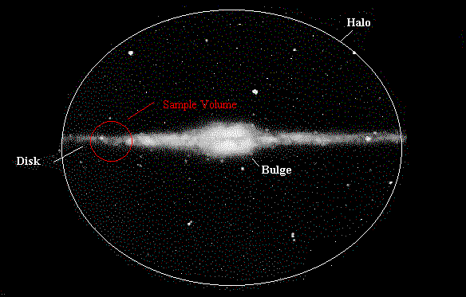
36. Galaxy Type:
a) Spiral
B) Barred-Spiral
C) Elliptical
D) Irregular

Exceeds
24. Besides shape, what is the difference between an elliptical galaxy and an irregular galaxy?

25. Explain the odd and irregular shapes of most asteroids.

H2E3. Describe how the universe galaxies, stars and planets evolve over time

____26. Describe what will happen to the hydrogen and helium in the sun over the next few billion years?

____27. What two forces keep the sun in equilibrium?

____28. How does a planets atmosphere affect its temperature?

____29. What is meant by the statement “The moon is geologically dead”?

____30. What does Hubble’s Law tell us?

____31. What evidence provides support for the big bang theory?

____32. What is dark matter?

____33. How did the moon form?

____34. What object in our solar system “took” almost all the mass when it formed?

Completion Complete each statement using the following words. (Not all words used)
Away Gravity Energy White Dwarf Asteroid Surface Rocks
Universe Dark Black Hole

35. Redshift shows that a galaxy is moving ___________ from us.
36. ________ Energy the force that is causing our universe to expand and accelerate
37. What is the major force that causes a nebula to develop into a star? ______________
38. When our Sun “dies” it will turn into a _________ ___________.
39. List the steps of the Big Bang Theory

40. List the steps in a star’s life cycle

41. Draw the steps in the formation of the solar system
Exceeds
42. What will happen to the amount of galaxies, stars and solar systems in our universe over the next few hundreds of billions of years?

