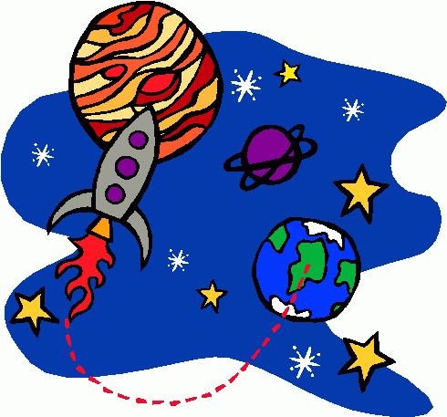
Name ____________________________________

Chapter 25 & 26 Notes: Space

- Everything that we can see and observe and is known to exist is called the .

- Universe is still and .
  - Hubble’s Law: says that the _______________ at which a galaxy is moving away is proportional to its ____________________ from us.
    - Galaxies __________ to us are moving away from us .
    - Galaxies ____________ from us are moving away .
  - Observations of __________________ show a shift in their spectra
    - Redshift means the galaxy is moving ____________ and ___________________ the light waves
    - Blueshift means the galaxy is moving _______________ us and _______________________ the light waves

- If galaxies are continually moving away, then if we _____________ their movement, it takes us back to a single ____________ in space and time.
  - The single point is called a __________ singularity or _______________________ singularity.
  - Contained all ______________ and ________________ ever to exist.
  - This point expanded rapidly, suddenly, like an explosion. This sudden expansion is called the B______ B_______ Theory.
    - H_____________ and h_____________ atoms formed first as universe cooled
    - Hydrogen forms into ___________, and starts fusion
  - Dark Energy is the force that is causing our universe to e_____________ and _a_______________________.

- Galaxy: a huge group of individual ________, star systems, star clusters, ________, and __________ bound together by ____________________.
  - We live in the M________ W______ Galaxy
    - ________ – _________ Billion stars in our galaxy
    - Diameter is __________________ light years
    - Takes ________ million years for our sun to complete ____ orbit
    - We are a ________-spiral galaxy

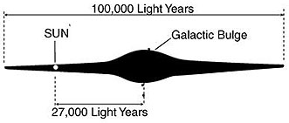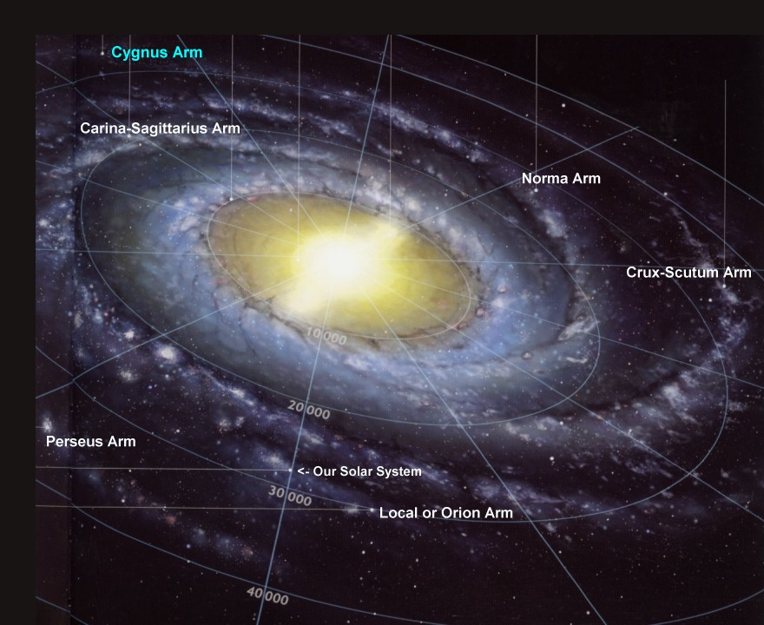
Side View of MWG Top View of MWG

  - Galaxy classification is by shape, there are 4 types.
    - Spiral, Barred-Spiral, Elliptical, and Irregular

4 Types of Galaxies
Spiral | Elliptical
Barred-Spiral | Irregular

- Star Life Cycle:
  - Born in a Nebula (Hydrogen ______ and _______ cloud)
    - Gravity pulls it together. The gas gets so compressed that it ___________, this is called a p__________________.
    - Gravity keeps compressing until Hydrogen atoms are ____________ into H_______________.
    - A star is formed when n_____________ f_____________ begins.
  - Adult Star- different s________, temp, c_________ and luminosities.
  - A star dies when run out of _________ (run out of atoms to fuse, can’t fuse past Iron)
    - If they are ____ solar masses or less, die as white dwarf
    - If they are ___________ solar masses, die as neutron star
    - If they are greater than _____ solar masses die as black hole

- Solar System Formation- The Nebular Theory:
  - Star is born from ________ and ________ coming together
  - Most of the mass (99%) goes into the center to form the ______
  - The left over matter _____________ together around the star
Formation of Our Solar System
Nebula comes together | Flattens into disk | Protostar is formed, planetessimals form
Protoplanets accrete &solar winds blow less dense material out |  | Planets finish morning with 8 planets. Still left over material

- Facts about planets in our solar system:
Mercury
Size:
Location:
Orbital plane
Atmosphere:
Primary Elements:
Planet made of:

Venus
Size:
Location:
Orbital plane
Atmosphere:
Primary Elements:
Planet made of:
Earth
Size:
Location:
Orbital plane
Atmosphere:
Primary Elements:
Planet made of:

Mars
Size:
Location:
Orbital plane
Atmosphere:
Primary Elements:
Planet made of:

Jupiter
Size:
Location:
Orbital plane
Atmosphere:
Primary Elements:
Planets made of:

Saturn
Size:
Location:
Orbital plane
Atmosphere:
Primary Elements:
Planets made of:

Uranus
Size:
Location:
Orbital plane
Atmosphere:
Primary Elements:
Planets made of:

Neptune
Size:
Location:
Orbital plane
Atmosphere:
Primary Elements:
Planets made of:

- Other objects in our solar system:
  - Comets: dusty pieces of ________ and ________ that partially vaporize when they pass near the sun.
  - Meteoroids: pieces of _________, usually less than a few hundred _________ in size, that travel through the solar system.
    - Meteor: when its falling through _____________________.
    - Meteorite: when it’s on the _____________________.
  - Asteroids: small, rocky solar-system bodies, most of which are found orbiting the sun in a region between M__________ and J______________.
    - These unaltered remnants show us the ______ of the solar system and what it originally was _________ from.

Standards to know for the test:

HIEI: Classify bodies in Solar System (properties & composition)
Describe attributes of our galaxy & evidence of multiple Galaxies.

(Sun, rock & gas planets, asteroids, comets, moons)
(Size, location, orbital path/plane, atmosphere, elements, % comp)
(Relative stellar mass, galaxy size/shape)

H2E3: Describe how the universe, galaxies, stars, and planets evolve over time.

(Big Bang, expanding still, H and He formed 1st)
(Accretion, star life cycle, fusion cycle)
(Solar system formation, meteor evidence)

