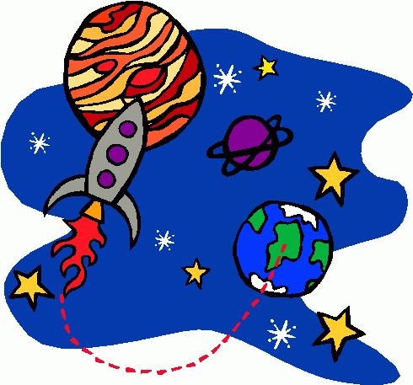
Name ____________________________________

Chapter 25 & 26 Notes: Space

- Everything that we can see and observe and is known to exist is called the Universe.

- Universe is still expanding and accelerating
  - Hubble’s Law: says that the speed at which a galaxy is moving away is proportional to its distance from us.
    - Galaxies closer to us are moving away from us slower
    - Galaxies further from us are moving away faster
  - Observations of galaxies show a shift in their spectra
    - Redshift means the galaxy is moving away and stretching the light waves
    - Blueshift means the galaxy is moving towards us and compressing the light waves

- If galaxies are continually moving away, then if we rewind their movement, it takes us back to a single point in space and time.
  - The single point is called a naked singularity or primordial singularity.
  - Contained all matter and energy ever to exist.
  - This point expanded rapidly, suddenly, like an explosion. This sudden expansions is called the Big Bang Theory.
    - Hydrogen and helium atoms formed first as universe cooled.
    - Hydrogen forms into stars, and starts fusion
  - Dark Energy is the force that is causing our universe to expand and accelerate.

- Galaxy: a huge group of individual stars, star systems, star clusters, dust, and gas bound together by gravity.
  - We live in the Milky Way Galaxy
    - 200 – 400 Billion stars in our galaxy
    - Diameter is 100,000 light years
    - Takes 220 million years for our sun to complete one orbit
    - We are a bared-spiral galaxy

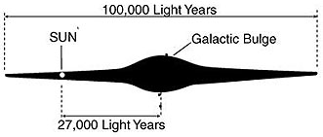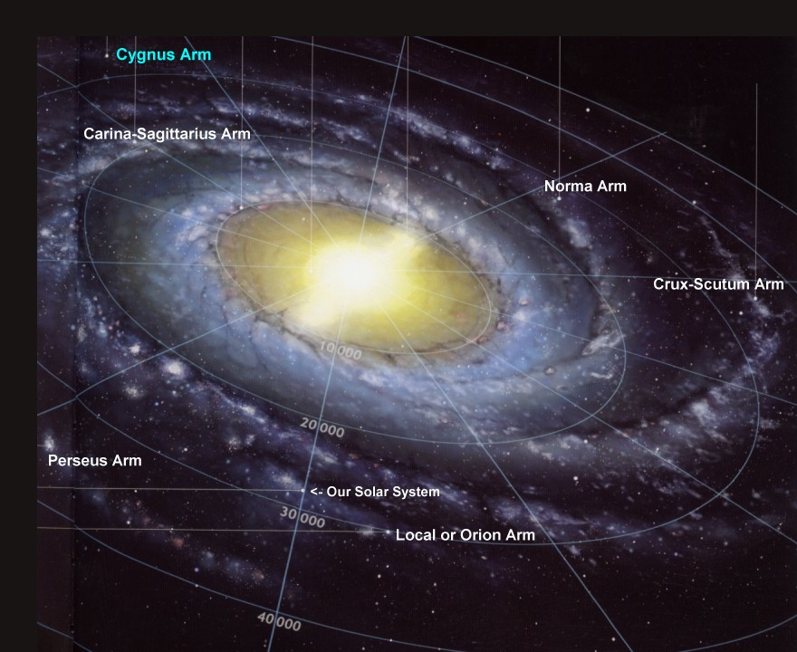
Side View of MWG Top View of MWG

  - Galaxy classification is by shape, there are 4 types.
    - Spiral, Barred-Spiral, Elliptical, and Irregular

4 Types of Galaxies
Spiral | Elliptical
Barred-Spiral | Irregular

- Star Life Cycle:
  - Born in a Nebula (Hydrogen gas and dust cloud)
    - Gravity pulls it together. The gas gets so compressed that it glows, this is called a protostar.
    - Gravity keeps compressing until Hydrogen atoms are fused into Helium.
    - A star is formed when nuclear fusion begins.
  - Adult Star- different sizes, temp, color and luminosities.
  - A star dies when run out of fuel (run out of atoms to fuse, can’t fuse past Iron)
    - If they are 8 solar masses or less, die as white dwarf
    - If they are 9-25 solar masses, die as neutron star
    - If they are greater than 25 solar masses die as black hole

- Solar System Formation- The Nebular Theory:
  - Star is born from gas and dust coming together
  - Most of the mass (99%) goes into the center to form the star
  - The left over matter clumps together around the star
Formation of Our Solar System
Nebula comes together | Flattens into disk | Protostar is formed, planetessimals form
Protoplanets accrete &solar winds blow less dense material out |  | Planets finish morning with 8 planets. Still left over material

- Facts about planets in our solar system:
Mercury
Size:
Location:
Orbital plane
Atmosphere:
Primary Elements:
Planet made of:

Venus
Size:
Location:
Orbital plane
Atmosphere:
Primary Elements:
Planet made of:
Earth
Size:
Location:
Orbital plane
Atmosphere:
Primary Elements:
Planet made of:

Mars
Size:
Location:
Orbital plane
Atmosphere:
Primary Elements:
Planet made of:

Jupiter
Size:
Location:
Orbital plane
Atmosphere:
Primary Elements:
Planets made of:

Saturn
Size:
Location:
Orbital plane
Atmosphere:
Primary Elements:
Planets made of:

Uranus
Size:
Location:
Orbital plane
Atmosphere:
Primary Elements:
Planets made of:

Neptune
Size:
Location:
Orbital plane
Atmosphere:
Primary Elements:
Planets made of:

- Other objects in our solar system:
  - Comets: dusty pieces of ice and rock that partially vaporize when they pass near the sun.
  - Meteoroids: pieces of rock, usually less than a few hundred meters in size, that travel through the solar system.
    - Meteor: when its falling through atmosphere.
    - Meteorite: when its on the ground.
  - Asteroids: small, rocky solar-system bodies, most of which are found orbiting the sun in a region between Mars and Jupiter.
    - These unaltered remnants show us the age of the solar system and what it originally was made from.

Standards to know for the test:

HIEI: Classify bodies in Solar System (properties & composition)
Describe attributes of our galaxy & evidence of multiple Galaxies.

(Sun, rock & gas planets, asteroids, comets, moons)
(Size, location, orbital path/plane, atmosphere, elements, % comp)
(Relative stellar mass, galaxy size/shape)

H2E3: Describe how the universe, galaxies, stars, and planets evolve over time.

(Big Bang, expanding still, H and He formed 1st)
(Accretion, star life cycle, fusion cycle)
(Solar system formation, meteor evidence)

